UNIVERSITY OF CALIFORNIA, DAVIS
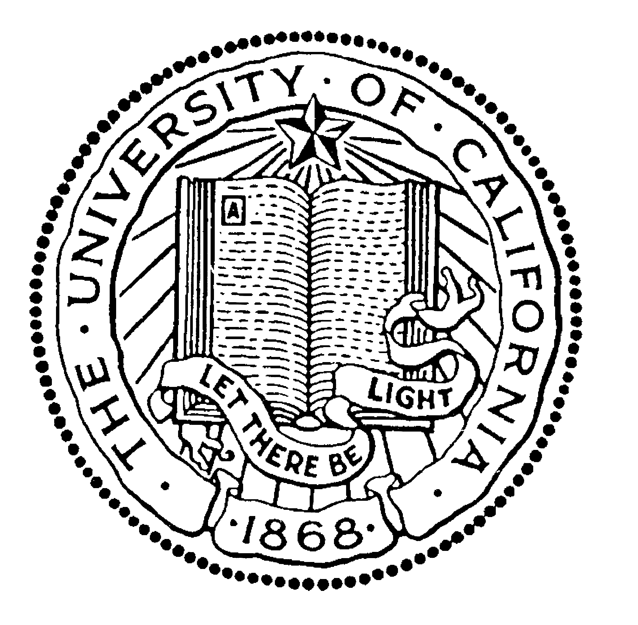

BERKELEY • DAVIS • IRVINE • LOS ANGELES • MERCED • RIVERSIDE • SAN DIEGO • SAN FRANCISCO SANTA BARBARA • SANTA CRUZ

9/24/2021
Re. Letter of endorsement for Katherine Lauck
To whom it may concern,
I am writing to formally endorse Katherine Lauck as an authorized student permittee on CDFW Scientific Collecting Permit. I serve as Katherine’s dissertation advisor within the Graduate Group of Ecology at UC Davis. As a 3rd year PhD student, Katie has designed a series of projects exploring the interactive effect of habitat conversion and climate change on bird communities. First, Katherine helped organize a lab project exploring the interactive effect of climate and land-use change on bird nesting success, leveraging a citizen science dataset of 152,863 nesting attempts across the U.S. Her early results are groundbreaking. In agriculture, temperature spikes reduced the probability of birds fledging young from >80% in normal years to <50%. In forests, the trend reversed with high temperatures increasing success.
In this permit application, Katherine is proposing to further explore how forests, grasslands, orchards, and row crops modify impacts of temperature spikes on nesting birds. Specifically, across a network of nest boxes, she will use climate loggers, remote cameras, and lab analyses to associate nestling physiology, growth, and survival with nest microclimates and food provisioning. Her work will provide key insights into how land use and climate affect avian fitness and results of direct relevance to managing wildlife in farming landscapes.
Katie’s passion for outreach and education is just as inspiring as her research prowess. She has trained dozens of students, community members, and practitioners worldwide in ecological field methods and tree climbing techniques. Moreover, as a consultant for the NGO ‘Planet Indonesia,’ she developed environmental education programs and mentored young Indonesian scientists, one of whom won a Chevening Scholarship. Katie has also taken leadership roles at UC Davis, evidenced by her being elected co-chair of her graduate student association. Finally, Katie recently joined a new taskforce aimed at restructuring the graduate program to increase diversity and inclusion.
To sum up, Katie is rocketing off to an exceptional career in ecology and conservation science. She couples unbridled passion for conservation with incredible ambition and scientific curiosity. She has proved herself a relentless field researcher, meticulous modeler, and effective communicator. Equally important, she is a stellar community member, exceptionally giving with her time, eager to form new collaborations, and ready to take on important leadership roles.
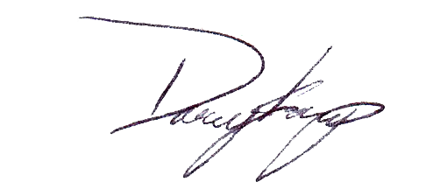
Sincerely,

Daniel S. Karp
Assistant Professor
Department of Wildlife, Fish, and Conservation Biology
University of California, Davis

